STA 211: Probability II
Revised and Enhanced Edition
Ibadan Distance Learning Centre Series
Updated teaching edition, 2026
Original text: S. O. Oyamakin Ph.D., Department of Statistics, University of Ibadan

Table of Contents
- Preface to the Updated Edition
- How to Use This Course Guide
- General Introduction and Course Objectives
- Lecture One: Further Permutations and Combinations
- Lecture Two: Permutations Involving Elements that are Alike
- Lecture Three: Probability Laws
- Lecture Four: Conditional Probability, Independence and Bayes’ Rule
- Lecture Five: Random Variables, Expectations and Moments
- Lecture Six: Markov’s and Chebyshev’s Inequalities
- Lecture Seven: The Bernoulli and Binomial Distributions
- Lecture Eight: The Negative Binomial and Geometric Distributions
- Lecture Nine: The Poisson Distribution
- Lecture Ten: The Hypergeometric Distribution
- Lecture Eleven: The Uniform or Rectangular Distribution
- Lecture Twelve: The Normal Distribution
- Lecture Thirteen: Joint, Marginal and Conditional Distributions
- Lecture Fourteen: Distributions of Functions of Random Variables
- Lecture Fifteen: The Gamma and Chi-Square Distributions
- Consolidated Formula Sheet
- Revision Notes
- References

Preface to the Updated Edition
This edition retains the fifteen-lectw∑∑∑∑∑∑∑∑∑∑∑∑∑∑∑ ure structure of the supplied STA 211: Probability II manuscript while improving mathematical accuracy, sequencing and readability. The principal revision is the replacement of fragmented or image-based notation with editable Word equations. Definitions, assumptions and parameterisations are stated explicitly, and each major result is followed by interpretation, a worked example and a short set of review questions.
The update also strengthens several conceptual links that are essential for later statistical work. These include the distinction between mutually exclusive and independent events, the relationship between probability mass functions, probability density functions and cumulative distribution functions, the role of moment generating functions, finite-population correction in sampling without replacement, additivity of selected distribution families, and the connection between transformations, convolution and the Central Limit Theorem.
The material has been synthesised from the supplied course document and probability notes by Walrand, Kroese, Gravner, Young, Cameron, Doedel and other accompanying lecture materials. The wording, examples and organisation in this edition are original to this revision; the listed sources were used to check standard results, notation and topic coverage.

How to Use This Course Guide
Each lecture contains six components:
- Learning objectives, which identify the skills students should acquire.
- A short pre-test, which activates prerequisite knowledge.
- Core exposition, with definitions, formulas and interpretation.
- Worked examples, showing a disciplined solution method.
- Common errors, highlighting mistakes that frequently occur in examinations.
- Post-test questions and selected answers, for independent practice.
Students should not attempt to memorise formulas in isolation. For each distribution, learn the random experiment, the support, the probability function, the parameters, the mean and variance, and the assumptions that make the model appropriate.

General Introduction
Probability provides a mathematical language for uncertainty. A probability model begins with a random experiment, identifies the possible outcomes, groups outcomes into events and assigns probabilities consistently. The same framework supports applications in quality control, engineering reliability, finance, public health, agriculture, telecommunications and scientific research.
The course is organised into three broad sections:
- Counting and probability laws: Lectures One to Four.
- Random variables and discrete distributions: Lectures Five to Ten.
- Continuous, joint and transformed distributions: Lectures Eleven to Fifteen.

Course Objectives
By the end of the course, students should be able to:
- construct sample spaces and events for random experiments;
- apply permutations, combinations and multinomial counting methods;
- use the axioms and laws of probability, including conditional probability and Bayes’ theorem;
- define random variables and calculate expectations, variances and moments;
- identify and apply standard discrete and continuous probability distributions;
- derive marginal and conditional distributions from joint distributions;
- transform random variables using distribution and Jacobian methods; and
- explain the probabilistic foundations of the Law of Large Numbers and the Central Limit Theorem.

Core Notation
Symbol | Meaning
$$Ω$$ | sample space
$$A,B,C$$ | events
$$A^{c}$$ | complement of $A$
$$P\left(A\right)$$ | probability of event $A$
$$P\left(A∣B\right)$$ | conditional probability of $A$ given $B$
$$X,Y$$ | random variables
$$p_{X}\left(x\right)$$ | probability mass function of a discrete random variable
$$f_{X}\left(x\right)$$ | probability density function of a continuous random variable
$$F_{X}\left(x\right)$$ | cumulative distribution function
$$E\left(X\right)$$ | expected value of $X$
$$Var\left(X\right)$$ | variance of $X$
$$M_{X}\left(t\right)$$ | moment generating function of $X$

LECTURE ONE: Further Permutations and Combinations

Introduction
Many elementary probability calculations reduce to counting. When all outcomes in a finite sample space are equally likely,
$$P\left(A\right)=\frac{\text{number of outcomes favourable to }A}{\text{total number of outcomes}}.$$
The difficulty is usually not the final division but the accurate counting of outcomes. Permutations are used when order matters; combinations are used when order does not matter.

Learning Objectives
By the end of this lecture, you should be able to:
- apply the fundamental counting principle;
- distinguish permutations from combinations;
- derive and use $n!$, $​_{n}P_{r}$ and $\left({n \atop r}\right)$; and
- solve counting problems with restrictions.

Pre-Test
- How many three-digit codes can be formed from the digits 0 to 9 if repetition is allowed?
- Does the selection of three committee members depend on the order in which they are named?

The Fundamental Counting Principle
If a procedure has $k$ successive stages and stage $i$ can be completed in $n_{i}$ ways, then the whole procedure can be completed in
$$N=n_{1}n_{2}⋯n_{k}$$
ways, provided the number of choices at each stage is correctly determined after earlier choices have been made.

Example 1.1: Product choices
A cafeteria offers 4 main dishes, 3 side dishes and 2 drinks. The number of distinct meals containing one item from each category is
$$4×3×2=24.$$

Factorials and Permutations
For a positive integer $n$,
$$n!=n\left(n-1\right)\left(n-2\right)⋯2⋅1,$$
with the convention $0!=1$.
The number of ordered arrangements of $r$ objects selected without replacement from $n$ distinct objects is
$$​_{n}P_{r}=n\left(n-1\right)⋯\left(n-r+1\right)=\frac{n!}{\left(n-r\right)!}.$$
When all $n$ objects are arranged,
$$​_{n}P_{n}=n!.$$

Example 1.2: Office holders
A committee of 10 members must choose a chairperson, secretary and treasurer. Since the offices are different, order matters:
$$​_{10}P_{3}=10×9×8=720.$$

Combinations
The number of unordered selections of $r$ objects from $n$ distinct objects is
$$\left({n \atop r}\right)=​_{n}C_{r}=\frac{n!}{r!\left(n-r\right)!}, 0≤r≤n.$$
Each combination of $r$ objects can be arranged in $r!$ orders, so
$$​_{n}P_{r}=r!\left({n \atop r}\right).$$
Useful identities include
$$\left({n \atop r}\right)=\left({n \atop n-r}\right),$$
$$\left({n \atop 0}\right)=\left({n \atop n}\right)=1,$$
and Pascal’s identity,
$$\left({n \atop r}\right)=\left({n-1 \atop r-1}\right)+\left({n-1 \atop r}\right).$$

Example 1.3: Committee composition
A committee of 4 is selected from 7 lecturers and 5 postgraduate students.
(a) No restriction
$$\left({12 \atop 4}\right)=495.$$
(b) Exactly 2 lecturers and 2 students
$$\left({7 \atop 2}\right)\left({5 \atop 2}\right)=21×10=210.$$

Example 1.4: At least condition
From 6 men and 4 women, form a committee of 5 containing at least 3 women. The mutually exclusive possibilities are 3 women and 2 men, or 4 women and 1 man:
$$\left({4 \atop 3}\right)\left({6 \atop 2}\right)+\left({4 \atop 4}\right)\left({6 \atop 1}\right)=4\left(15\right)+1\left(6\right)=66.$$

Restricted Arrangements
Restrictions often require a case split, a block method or complementary counting.

Example 1.5: Two books together
Five distinct books are arranged on a shelf, and two specified books must be adjacent. Treat the pair as one block. The block and the other three books give $4!$ arrangements; the two books within the block can be ordered in $2!$ ways:
$$4! 2!=48.$$

Common Errors
- Using combinations when offices or positions are distinct.
- Treating the first digit of a number as though it may be zero.
- Adding counts for cases that overlap.
- Forgetting that choices change when sampling is without replacement.

Summary
Situation | Formula
Arrange all $n$ distinct objects | $$n!$$
Arrange $r$ from $n$ distinct objects | $$​_{n}P_{r}=\frac{n!}{\left(n-r\right)!}$$
Select $r$ from $n$ distinct objects | $$\left({n \atop r}\right)=\frac{n!}{r!\left(n-r\right)!}$$

Post-Test
- Evaluate $​_{12}P_{4}$ and $\left({12 \atop 4}\right)$.
- How many 5-letter strings can be formed from 26 letters if repetition is not allowed?
- A class contains 8 women and 7 men. How many committees of 5 contain exactly 3 women?
- In how many ways can 7 people sit in a row if two specified people must not sit together?
- A password contains 3 distinct letters followed by 2 distinct digits. How many passwords are possible?
Selected answers: 1. $11,880$ and $495$; 2. $​_{26}P_{5}$; 3. $\left({8 \atop 3}\right)\left({7 \atop 2}\right)=1,176$; 4. $7!-2\left(6!\right)=3,600$; 5. $​_{26}P_{3} ​_{10}P_{2}=1,404,000$.

LECTURE TWO: Permutations Involving Elements that are Alike

Introduction
When some objects are indistinguishable, the ordinary factorial formula over-counts arrangements. The correction is made by dividing by the factorial of the number of repetitions of each type.

Learning Objectives
You should be able to:
- count distinguishable arrangements with repeated elements;
- apply the multinomial coefficient and multinomial theorem;
- count circular permutations; and
- distinguish linear, circular and reflected arrangements.

Pre-Test
- How many distinct arrangements are possible for the letters in LEVEL?
- Why is the number of arrangements around a round table not $n!$?

Repeated Elements
Suppose $n$ objects consist of $n_{1}$ objects of type 1, $n_{2}$ of type 2, …, $n_{k}$ of type $k$, where
$$n_{1}+n_{2}+⋯+n_{k}=n.$$
The number of distinguishable linear arrangements is
$$\frac{n!}{n_{1}!n_{2}!⋯n_{k}!}.$$

Example 2.1: CALCULUS
The word CALCULUS has 8 letters, with C, L and U each repeated twice. Therefore,
$$\frac{8!}{2!2!2!}=5,040.$$

Example 2.2: Binary response patterns
A questionnaire has 10 Yes/No questions. A response pattern containing exactly 6 Yes responses and 4 No responses can be arranged in
$$\frac{10!}{6!4!}=\left({10 \atop 6}\right)=210$$
ways.

The Multinomial Coefficient
The coefficient
$$\left({n \atop n_{1},n_{2},…,n_{k}}\right)=\frac{n!}{n_{1}!n_{2}!⋯n_{k}!}$$
counts the number of ways to divide $n$ distinct positions into labelled groups of sizes $n_{1},n_{2},…,n_{k}$.
The multinomial theorem is
x1+x2+⋯+xkn=n1+⋯+nk=n​n!n1!⋯nk!x1n1⋯xknk.

Example 2.3: Coefficient in an expansion
The coefficient of $x^{3}y^{2}z$ in ${\left(x+y+z\right)}^{6}$ is
$$\frac{6!}{3!2!1!}=60.$$

Circular Permutations
For $n$ distinct objects arranged around a circle, rotations are regarded as identical. Fix one object and arrange the remaining $n-1$ objects:
$$N=\left(n-1\right)!.$$
If clockwise and anticlockwise arrangements are also regarded as identical, as in a necklace that may be turned over, then for $n>2$ the count is usually
$$N=\frac{\left(n-1\right)!}{2}.$$
This division by 2 is valid only when each reflected arrangement has a distinct mirror image and no additional symmetry changes the count.

Example 2.4: Round-table seating
Nine people sit around a round table. The number of distinct seatings is
$$\left(9-1\right)!=8!=40,320.$$

Example 2.5: Alternating seats
Four men and four women sit around a round table in alternating order. Arrange the four men around the circle in $\left(4-1\right)!$ ways. Then place the four women in the four gaps in $4!$ ways:
$$3! 4!=144.$$

Summary
The central principle is to divide the factorial count by the number of internal rearrangements that do not create visibly different outcomes.

Post-Test
- Find the number of distinct arrangements of STATISTICS.
- Find the coefficient of $a^{2}b^{3}c$ in ${\left(a+b+c\right)}^{6}$.
- In how many ways can 7 people sit around a round table?
- In how many ways can 5 married couples sit around a round table if men and women alternate?
- How many sequences of 12 outcomes contain 5 successes, 4 failures of type 1 and 3 failures of type 2?
Selected answers: 1. $\frac{10!}{3!3!2!}=50,400$; 2. $60$; 3. $6!=720$; 4. $4!5!=2,880$; 5. $\frac{12!}{5!4!3!}=27,720$.

LECTURE THREE: Probability Laws

Introduction
A probability model is a triple $\left(Ω,F,P\right)$ consisting of a sample space, a collection of events and a probability measure. The axioms are few, but they generate the principal laws used throughout probability and statistics.

Learning Objectives
You should be able to:
- define a sample space, event and probability measure;
- state and apply the probability axioms;
- use complement, addition and inclusion-exclusion laws;
- apply De Morgan’s laws; and
- distinguish mutually exclusive and exhaustive events.

Pre-Test
- What is the sample space for two tosses of a coin?
- Can two events overlap and still be distinct?

Views of Probability
Three common interpretations are useful:
- Classical: based on equally likely outcomes.
- Relative-frequency: probability is the long-run proportion of occurrence in repeated trials.
- Subjective or Bayesian: probability represents a coherent degree of belief, updated when evidence becomes available.
The mathematical laws are the same once probabilities have been assigned.

Axioms of Probability
For every event $A∈F$:
- Non-negativity: $P\left(A\right)≥0$.
- Normalisation: $P\left(Ω\right)=1$.
- Countable additivity: if $A_{1},A_{2},…$ are pairwise disjoint, then
$$P\left(\underset{i=1}{\overset{∞}{⋃}}A_{i}\right)=\sum_{i=1}^{∞}{P}\left(A_{i}\right).$$

Immediate Consequences
The impossible event has probability zero:
$$P\left(⌀\right)=0.$$
The complement rule is
$$P\left(A^{c}\right)=1-P\left(A\right).$$
If $A⊆B$, then
$$P\left(A\right)≤P\left(B\right).$$
For any events $A$ and $B$,
$$P\left(A\backslash B\right)=P\left(A\right)-P\left(A∩B\right).$$

Addition Law and Inclusion-Exclusion
For two events,
$$P\left(A∪B\right)=P\left(A\right)+P\left(B\right)-P\left(A∩B\right).$$
The subtraction is required because outcomes in $A∩B$ are included twice in $P\left(A\right)+P\left(B\right)$.
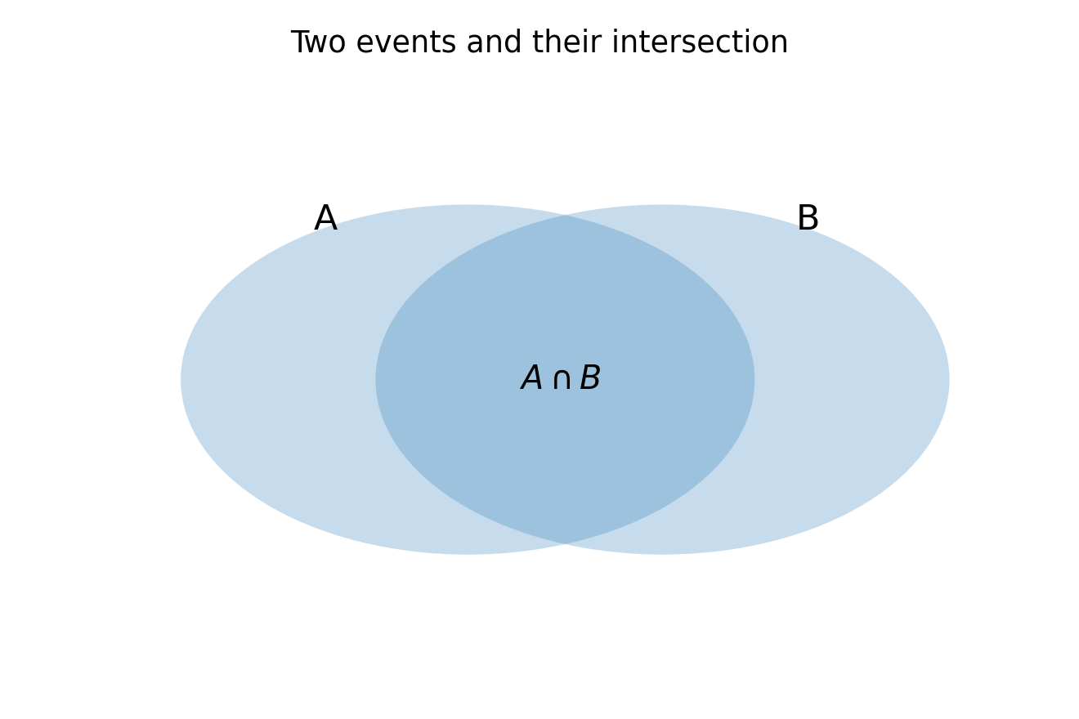
Two events and their intersection
For three events,
$$\begin{matrix}P\left(A∪B∪C\right)=​ & P\left(A\right)+P\left(B\right)+P\left(C\right) \\ & -P\left(A∩B\right)-P\left(A∩C\right)-P\left(B∩C\right) \\ & +P\left(A∩B∩C\right).\end{matrix}$$

Example 3.1: Survey responses
In a survey, 60% use mobile banking, 45% use internet banking and 30% use both. The probability that a randomly selected respondent uses at least one service is
$$0.60+0.45-0.30=0.75.$$
The probability of using neither service is
$$1-0.75=0.25.$$

De Morgan’s Laws
The complements of unions and intersections satisfy
$${\left(A∪B\right)}^{c}=A^{c}∩B^{c},$$
$${\left(A∩B\right)}^{c}=A^{c}∪B^{c}.$$
Thus, “not at least one” means “none”, and “not both” means “at least one fails”.

Example 3.2: At least one success
If independent trials have success probability $p_{i}$ on trial $i$, the probability of at least one success is often easiest to calculate by the complement:
$$P\left(\text{at least one success}\right)=1-\prod_{i=1}^{n}{\left(1-p_{i}\right)}.$$
For four fair die rolls, the probability of at least one six is
$$1-{\left(\frac{5}{6}\right)}^{4}≈0.5177.$$

Mutually Exclusive and Exhaustive Events
Events are mutually exclusive if
$$A∩B=⌀.$$
A collection $A_{1},…,A_{k}$ is exhaustive if
$$\underset{i=1}{\overset{k}{⋃}}A_{i}=Ω.$$
A mutually exclusive and exhaustive collection forms a partition of the sample space.

Common Errors
- Adding $P\left(A\right)$ and $P\left(B\right)$ without subtracting the overlap.
- Confusing “mutually exclusive” with “independent”.
- Assuming outcomes are equally likely without justification.
- Treating $P\left(A∩B\right)$ as $P\left(A\right)P\left(B\right)$ before independence has been established.

Post-Test
- If $P\left(A\right)=0.55$, $P\left(B\right)=0.40$ and $P\left(A∩B\right)=0.20$, find $P\left(A∪B\right)$.
- If $P\left(A∪B\right)=0.80$, $P\left(A\right)=0.60$ and $P\left(B\right)=0.45$, find $P\left(A∩B\right)$.
- State the three-event inclusion-exclusion formula.
- A fair coin is tossed five times. Find the probability of at least one head.
- If $A⊆B$, explain why $P\left(A\right)≤P\left(B\right)$.
Selected answers: 1. $0.75$; 2. $0.25$; 4. $1-{\left(1/2\right)}^{5}=31/32$.

LECTURE FOUR: Conditional Probability, Independence and Bayes’ Rule

Introduction
Conditional probability revises the probability of an event when additional information is available. It is the foundation of diagnostic testing, classification, reliability analysis, risk assessment and Bayesian inference.

Learning Objectives
You should be able to:
- calculate conditional probabilities;
- use multiplication and chain rules;
- test event independence;
- apply the law of total probability; and
- use Bayes’ theorem to reverse conditioning.

Pre-Test
- What does $P\left(A∩B\right)$ represent?
- If a card is drawn from a standard deck and is known to be red, how many possible cards remain?

Conditional Probability
For events $A$ and $B$ with $P\left(B\right)>0$,
$$P\left(A∣B\right)=\frac{P\left(A∩B\right)}{P\left(B\right)}.$$
Conditioning restricts the sample space to $B$ and then measures the proportion of $B$ that also lies in $A$.

Example 4.1: Two coin tosses
A fair coin is tossed twice. Given that at least one head occurred, find the probability that the second toss was a head.
The restricted outcomes are $HH,HT,TH$. Two of these have a head on the second toss, so
$$P\left(\text{second is H}∣\text{at least one H}\right)=\frac{2}{3}.$$

Multiplication and Chain Rules
Rearranging the definition gives
$$P\left(A∩B\right)=P\left(B\right)P\left(A∣B\right)=P\left(A\right)P\left(B∣A\right).$$
For three events,
$$P\left(A∩B∩C\right)=P\left(A\right)P\left(B∣A\right)P\left(C∣A∩B\right).$$
More generally,
$$P\left(\underset{i=1}{\overset{n}{⋂}}A_{i}\right)=P\left(A_{1}\right)\prod_{i=2}^{n}{P}\left(A_{i}∣A_{1}∩⋯∩A_{i-1}\right).$$

Example 4.2: Sampling without replacement
A box contains 10 red and 10 green balls. Three balls are drawn without replacement. The probability that all are red is
$$\frac{10}{20}⋅\frac{9}{19}⋅\frac{8}{18}=\frac{2}{19}≈0.1053.$$

Independence
Events $A$ and $B$ are independent if
$$P\left(A∩B\right)=P\left(A\right)P\left(B\right).$$
When $P\left(B\right)>0$, this is equivalent to
$$P\left(A∣B\right)=P\left(A\right).$$
Independence means that knowledge of one event does not alter the probability of the other.

Mutual versus pairwise independence
Events $A_{1},A_{2},A_{3}$ are mutually independent if all pairwise factorisations hold and
$$P\left(A_{1}∩A_{2}∩A_{3}\right)=P\left(A_{1}\right)P\left(A_{2}\right)P\left(A_{3}\right).$$
Pairwise independence alone does not guarantee mutual independence.

Mutually exclusive is not independent
If $A$ and $B$ are mutually exclusive with positive probabilities, then $P\left(A∩B\right)=0$ but $P\left(A\right)P\left(B\right)>0$. Therefore, they are dependent.

Probability Trees
A tree diagram makes sequential conditioning explicit. Probabilities multiply along a path and add across mutually exclusive paths.
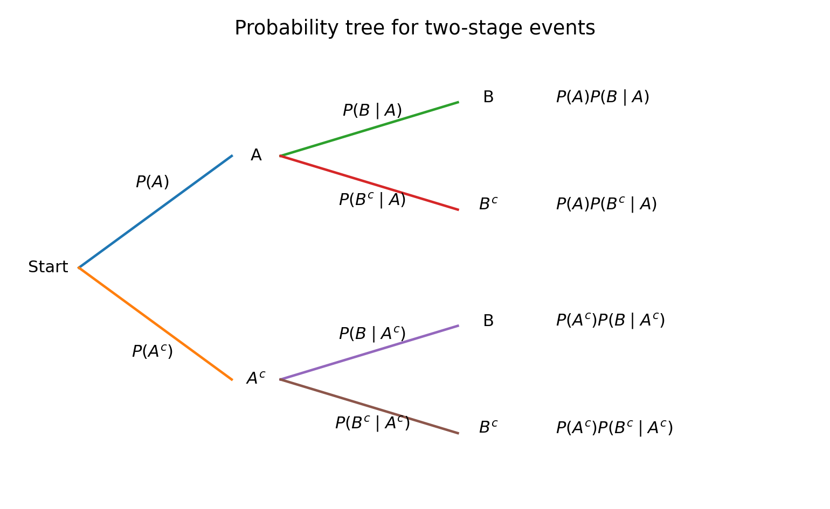
Probability tree for two-stage events

Law of Total Probability
If $A_{1},…,A_{k}$ form a partition of $Ω$ and $P\left(A_{i}\right)>0$, then for any event $B$,
$$P\left(B\right)=\sum_{i=1}^{k}{P}\left(B∣A_{i}\right)P\left(A_{i}\right).$$

Example 4.3: Damaged goods
A company receives 70% of its goods from supplier A and 30% from supplier B. The damage rates are 4% and 7%, respectively. Then
$$P\left(D\right)=0.04\left(0.70\right)+0.07\left(0.30\right)=0.049.$$

Bayes’ Theorem
For a partition $A_{1},…,A_{k}$ and evidence $B$,
$$P\left(A_{j}∣B\right)=\frac{P\left(B∣A_{j}\right)P\left(A_{j}\right)}{\sum_{i=1}^{k}{P}\left(B∣A_{i}\right)P\left(A_{i}\right)}.$$
Bayes’ theorem combines a prior probability $P\left(A_{j}\right)$ with the likelihood $P\left(B∣A_{j}\right)$ to obtain the posterior probability $P\left(A_{j}∣B\right)$.

Example 4.4: Medical screening
Suppose disease prevalence is 2%, sensitivity is 95%, and specificity is 90%. Let $D$ denote disease and $+$ a positive test.
$$P\left(D\right)=0.02, P\left(+∣D\right)=0.95,$$
$$P\left(+∣D^{c}\right)=1-0.90=0.10.$$
The total probability of a positive test is
$$P\left(+\right)=0.95\left(0.02\right)+0.10\left(0.98\right)=0.117.$$
Therefore,
$$P\left(D∣+\right)=\frac{0.95\left(0.02\right)}{0.117}≈0.1624.$$
Although the test is sensitive, most positive results are false positives because the disease is uncommon.

Post-Test
- If $P\left(A\right)=0.6$, $P\left(B\right)=0.5$ and $P\left(A∩B\right)=0.3$, are $A$ and $B$ independent?
- A bag has 6 white and 4 black balls. Two are drawn without replacement. Find the probability that both are white.
- A factory has three machines producing 50%, 30% and 20% of output, with defect rates 1%, 2% and 4%. Find the overall defect rate.
- For Question 3, find the probability that a defective item came from machine 3.
- Explain why mutually exclusive positive-probability events cannot be independent.
Selected answers: 1. Yes; 2. $\frac{6}{10}\frac{5}{9}=\frac{1}{3}$; 3. $0.019$; 4. $0.008/0.019≈0.4211$.

LECTURE FIVE: Random Variables, Expectations and Moments

Introduction
A random variable assigns a numerical value to each outcome of a random experiment. This permits probability questions to be expressed in algebraic form and provides the basis for probability distributions, expectation and statistical modelling.

Learning Objectives
You should be able to:
- define discrete and continuous random variables;
- use probability mass, density and distribution functions;
- calculate expectations and variances;
- obtain moments and moment generating functions; and
- interpret skewness and kurtosis.

Random Variables and Distributions
A random variable is a measurable function
$$X:Ω→R.$$
A discrete random variable has a countable support and probability mass function
$$p_{X}\left(x\right)=P\left(X=x\right),$$
where
pXx≥0, x​pXx=1.
A continuous random variable has a probability density function $f_{X}\left(x\right)$ satisfying
$$f_{X}\left(x\right)≥0, \int_{-∞}^{∞}{f_{X}}\left(x\right) dx=1.$$
For a continuous random variable,
$$P\left(a<X≤b\right)=\int_{a}^{b}{f_{X}}\left(x\right) dx,$$
and $P\left(X=x\right)=0$ for every single point $x$.

Cumulative Distribution Function
For any random variable,
$$F_{X}\left(x\right)=P\left(X≤x\right).$$
The CDF is non-decreasing, right-continuous and satisfies
$$\lim_{x→-∞}F_{X}\left(x\right)=0, \lim_{x→∞}F_{X}\left(x\right)=1.$$
For a continuous random variable,
$$F_{X}\left(x\right)=\int_{-∞}^{x}{f_{X}}\left(u\right) du,$$
and, where differentiable,
$$f_{X}\left(x\right)=\frac{d}{dx}F_{X}\left(x\right).$$

Expectation
For a discrete random variable,
EX=x​xpXx.
For a continuous random variable,
$$E\left(X\right)=\int_{-∞}^{∞}{x}f_{X}\left(x\right) dx.$$
More generally, for a function $g$,
EgX=x​gxpXx
or
$$E\left[g\left(X\right)\right]=\int_{-∞}^{∞}{g}\left(x\right)f_{X}\left(x\right) dx.$$
This is often called the law of the unconscious statistician.

Variance and Moments
The variance is
$$Var\left(X\right)=E\left[{\left(X-μ\right)}^{2}\right], μ=E\left(X\right).$$
An equivalent computational formula is
$$Var\left(X\right)=E\left(X^{2}\right)-{\left[E\left(X\right)\right]}^{2}.$$
The standard deviation is
$$σ=\sqrt{Var\left(X\right)}.$$
The $r$th raw moment is
$$μ'_{r}=E\left(X^{r}\right),$$
and the $r$th central moment is
$$μ_{r}=E\left[{\left(X-μ\right)}^{r}\right].$$

Linearity
For constants $a$ and $b$,
$$E\left(aX+b\right)=aE\left(X\right)+b,$$
$$Var\left(aX+b\right)=a^{2}Var\left(X\right).$$
Expectation is linear even when random variables are dependent:
$$E\left(\sum_{i=1}^{n}{X_{i}}\right)=\sum_{i=1}^{n}{E}\left(X_{i}\right).$$

Moment Generating Function
The moment generating function is
$$M_{X}\left(t\right)=E\left(e^{tX}\right),$$
for values of $t$ in an open interval containing zero. If it exists, moments are obtained by differentiation:
$$M_{X}^{\left(r\right)}\left(0\right)=E\left(X^{r}\right).$$
For independent random variables $X$ and $Y$,
$$M_{X+Y}\left(t\right)=M_{X}\left(t\right)M_{Y}\left(t\right).$$

Skewness and Kurtosis
The coefficient of skewness is
$$γ_{1}=\frac{E\left[{\left(X-μ\right)}^{3}\right]}{σ^{3}}.$$
Positive skewness indicates a longer right tail; negative skewness indicates a longer left tail.
The kurtosis coefficient is
$$β_{2}=\frac{E\left[{\left(X-μ\right)}^{4}\right]}{σ^{4}},$$
and excess kurtosis is $γ_{2}=β_{2}-3$.

Example 5.1: Discrete distribution
Let $X$ have the distribution
$$x$$ | 0 | 1 | 2 | 3
$$P\left(X=x\right)$$ | 0.1 | 0.3 | 0.4 | 0.2
Then
$$E\left(X\right)=0\left(0.1\right)+1\left(0.3\right)+2\left(0.4\right)+3\left(0.2\right)=1.7,$$
$$E\left(X^{2}\right)=0+1\left(0.3\right)+4\left(0.4\right)+9\left(0.2\right)=3.7,$$
$$Var\left(X\right)=3.7-{\left(1.7\right)}^{2}=0.81.$$

Example 5.2: Finding a constant
Suppose $p_{X}\left(x\right)=kx$ for $x=1,2,3,4$. Since probabilities sum to one,
$$k\left(1+2+3+4\right)=1,$$
so $k=0.1$.

Post-Test
- State the defining properties of a PMF and a PDF.
- For the distribution $P\left(X=0\right)=0.2$, $P\left(X=1\right)=0.5$, $P\left(X=2\right)=0.3$, find $E\left(X\right)$ and $Var\left(X\right)$.
- If $Y=4X-3$, express $E\left(Y\right)$ and $Var\left(Y\right)$ in terms of $E\left(X\right)$ and $Var\left(X\right)$.
- Show that $M_{X}'\left(0\right)=E\left(X\right)$.
- Explain why a density value may exceed one without violating probability laws.
Selected answers: 2. $E\left(X\right)=1.1$, $Var\left(X\right)=0.49$; 3. $E\left(Y\right)=4E\left(X\right)-3$, $Var\left(Y\right)=16Var\left(X\right)$.

LECTURE SIX: Markov’s and Chebyshev’s Inequalities

Introduction
Probability inequalities provide bounds when the full distribution is unknown. Markov’s inequality uses only a non-negative mean; Chebyshev’s inequality uses the mean and variance. Their bounds may be conservative, but they hold for broad classes of distributions.

Learning Objectives
You should be able to:
- state and prove Markov’s inequality;
- derive Chebyshev’s inequality;
- calculate distribution-free probability bounds; and
- interpret the limits of these bounds.

Markov’s Inequality
If $X$ is non-negative and $a>0$, then
$$P\left(X≥a\right)≤\frac{E\left(X\right)}{a}.$$

Proof
Because $X≥a$ whenever the event $\{X≥a\}$ occurs,
$$X≥aI_{\{X≥a\}},$$
where $I$ is an indicator. Taking expectations gives
$$E\left(X\right)≥aP\left(X≥a\right),$$
and the result follows.

Example 6.1
If the mean monthly claim is ₦40,000, then without assuming a distribution,
$$P\left(X≥100,000\right)≤\frac{40,000}{100,000}=0.4.$$

Chebyshev’s Inequality
If $X$ has mean $μ$ and finite variance $σ^{2}$, then for every $k>0$,
$$P\left(\left|X-μ\right|≥kσ\right)≤\frac{1}{k^{2}}.$$
Equivalently,
$$P\left(\left|X-μ\right|<kσ\right)≥1-\frac{1}{k^{2}}.$$

Derivation
Apply Markov’s inequality to the non-negative variable ${\left(X-μ\right)}^{2}$:
$$\begin{matrix}P\left(\left|X-μ\right|≥kσ\right) & =P\left({\left(X-μ\right)}^{2}≥k^{2}σ^{2}\right) \\ & ≤\frac{E\left[{\left(X-μ\right)}^{2}\right]}{k^{2}σ^{2}} \\ & =\frac{1}{k^{2}}.\end{matrix}$$

Example 6.2: A numerical interval
A distribution has mean 50 and standard deviation 6. At least what proportion lies between 38 and 62?
The interval is $50±12=50±2\left(6\right)$, so $k=2$:
$$P\left(38<X<62\right)≥1-\frac{1}{2^{2}}=0.75.$$

Example 6.3: Required width
How many standard deviations are needed to guarantee at least 90% of observations?
We require
$$1-\frac{1}{k^{2}}≥0.90.$$
Thus $1/k^{2}≤0.10$, so
$$k≥\sqrt{10}≈3.162.$$

Chebyshev versus the Empirical Rule
Chebyshev’s inequality applies to any distribution with finite variance. For an approximately normal distribution, the empirical rule gives much tighter descriptive percentages: about 68%, 95% and 99.7% within 1, 2 and 3 standard deviations. These normal percentages should not be used when the shape is unknown.

Post-Test
- State the assumptions required for Markov’s inequality.
- A non-negative random variable has mean 12. Find an upper bound for $P\left(X≥48\right)$.
- A variable has mean 100 and variance 225. Find a lower bound for $P\left(70<X<130\right)$.
- Find $k$ such that Chebyshev guarantees at least 96% within $k$ standard deviations.
- Explain why Chebyshev’s bound may not equal the actual probability.
Selected answers: 2. $0.25$; 3. $1-1/2^{2}=0.75$; 4. $k≥5$.

LECTURE SEVEN: The Bernoulli and Binomial Distributions

Introduction
The Bernoulli distribution models a single trial with two outcomes. The Binomial distribution models the number of successes in a fixed number of independent Bernoulli trials with constant success probability.

Learning Objectives
You should be able to:
- identify Bernoulli and binomial experiments;
- derive their probability functions;
- calculate means, variances and MGFs;
- use cumulative and complementary probabilities; and
- apply the additivity property of binomial variables.

Bernoulli Distribution
Let $X=1$ for success and $X=0$ for failure. If $P\left(X=1\right)=p$ and $q=1-p$, then
$$p_{X}\left(x\right)=p^{x}q^{1-x}, x=0,1.$$
The mean and variance are
$$E\left(X\right)=p,$$
$$Var\left(X\right)=pq.$$
The MGF is
$$M_{X}\left(t\right)=q+pe^{t}.$$

Binomial Distribution
A random variable $X$ has a binomial distribution with parameters $n$ and $p$, written $X∼Bin\left(n,p\right)$, if:
- there are $n$ trials;
- each trial has two outcomes;
- trials are independent; and
- the success probability $p$ is constant.
The PMF is
$$P\left(X=x\right)=\left({n \atop x}\right)p^{x}q^{n-x}, x=0,1,…,n.$$
The term $\left({n \atop x}\right)$ counts the positions of the $x$ successes; $p^{x}q^{n-x}$ is the probability of any one such pattern.
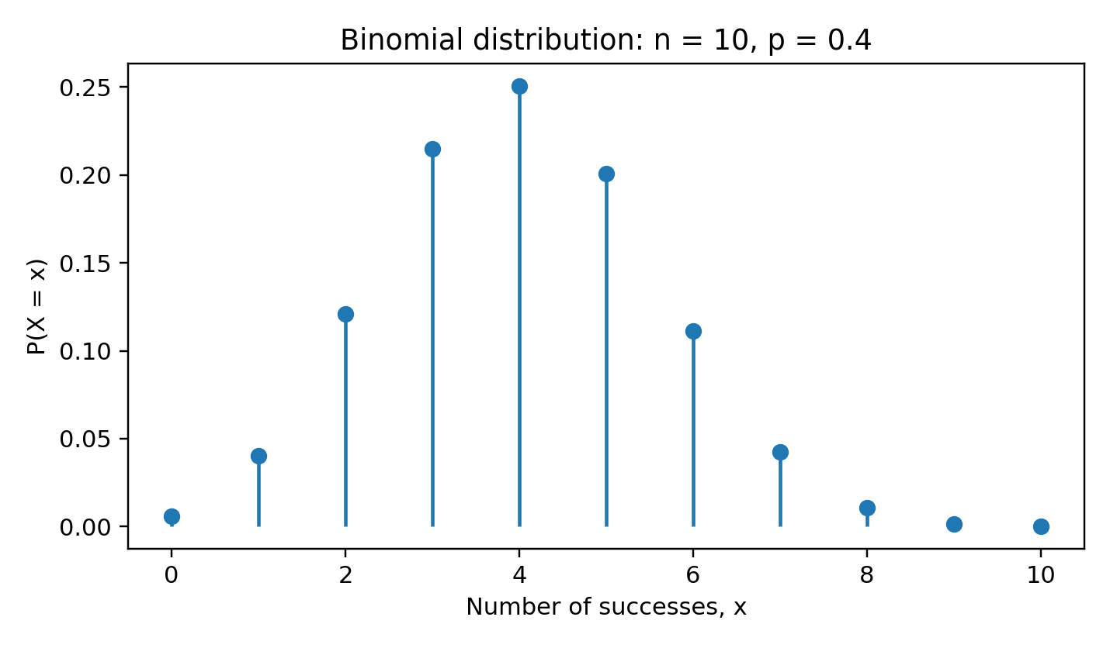
Binomial probability mass function
The mean and variance are
$$E\left(X\right)=np,$$
$$Var\left(X\right)=npq.$$
The MGF is
$$M_{X}\left(t\right)={\left(q+pe^{t}\right)}^{n}.$$

Useful Probability Forms
Exactly $x$ successes:
$$P\left(X=x\right)=\left({n \atop x}\right)p^{x}q^{n-x}.$$
At most $r$ successes:
$$P\left(X≤r\right)=\sum_{x=0}^{r}{\left({n \atop x}\right)}p^{x}q^{n-x}.$$
At least one success:
$$P\left(X≥1\right)=1-P\left(X=0\right)=1-q^{n}.$$
More than $r$ successes:
$$P\left(X>r\right)=1-P\left(X≤r\right).$$

Example 7.1
A production process has a 5% defect rate. In a random sample of 10 independent items, the probability of exactly 2 defects is
$$\left({10 \atop 2}\right){\left(0.05\right)}^{2}{\left(0.95\right)}^{8}≈0.0746.$$
The probability of at least one defect is
$$1-{\left(0.95\right)}^{10}≈0.4013.$$

Additivity
If $X∼Bin\left(n_{1},p\right)$ and $Y∼Bin\left(n_{2},p\right)$ are independent with the same success probability, then
$$X+Y∼Bin\left(n_{1}+n_{2},p\right).$$
The same $p$ is essential. If the success probabilities differ, the sum is not generally binomial.

Recurrence Relation
Successive probabilities satisfy
$$\frac{P\left(X=x+1\right)}{P\left(X=x\right)}=\frac{n-x}{x+1}\frac{p}{q}.$$
This relation can reduce repetitive calculation and helps locate the mode.

Post-Test
- State the four assumptions of a binomial model.
- If $X∼Bin\left(12,0.3\right)$, find $E\left(X\right)$ and $Var\left(X\right)$.
- Find $P\left(X=4\right)$ for the distribution in Question 2.
- A fair coin is tossed 8 times. Find the probability of at least 6 heads.
- Explain when the sum of two independent binomial variables is binomial.
Selected answers: 2. $3.6$ and $2.52$; 3. $\left({12 \atop 4}\right){\left(0.3\right)}^{4}{\left(0.7\right)}^{8}≈0.2311$; 4. $\sum_{x=6}^{8}{\left({8 \atop x}\right)}2^{-8}=37/256$.

LECTURE EIGHT: The Negative Binomial and Geometric Distributions

Introduction
The binomial model fixes the number of trials and counts successes. The negative binomial model reverses this structure: it fixes the required number of successes and counts how many trials are needed. The geometric distribution is the special case in which the first success is awaited.

Learning Objectives
You should be able to:
- identify negative binomial and geometric experiments;
- use their PMFs, means and variances;
- distinguish common support conventions; and
- explain the memoryless property of the geometric distribution.

Negative Binomial Distribution
Let $X$ be the trial on which the $r$th success occurs. For independent Bernoulli trials with success probability $p$ and $q=1-p$,
$$P\left(X=x\right)=\left({x-1 \atop r-1}\right)p^{r}q^{x-r}, x=r,r+1,….$$
The last trial must be a success. Among the first $x-1$ trials, exactly $r-1$ must be successes.
The mean and variance are
$$E\left(X\right)=\frac{r}{p},$$
$$Var\left(X\right)=\frac{rq}{p^{2}}.$$
The MGF is
$$M_{X}\left(t\right)={\left(\frac{pe^{t}}{1-qe^{t}}\right)}^{r}, qe^{t}<1.$$
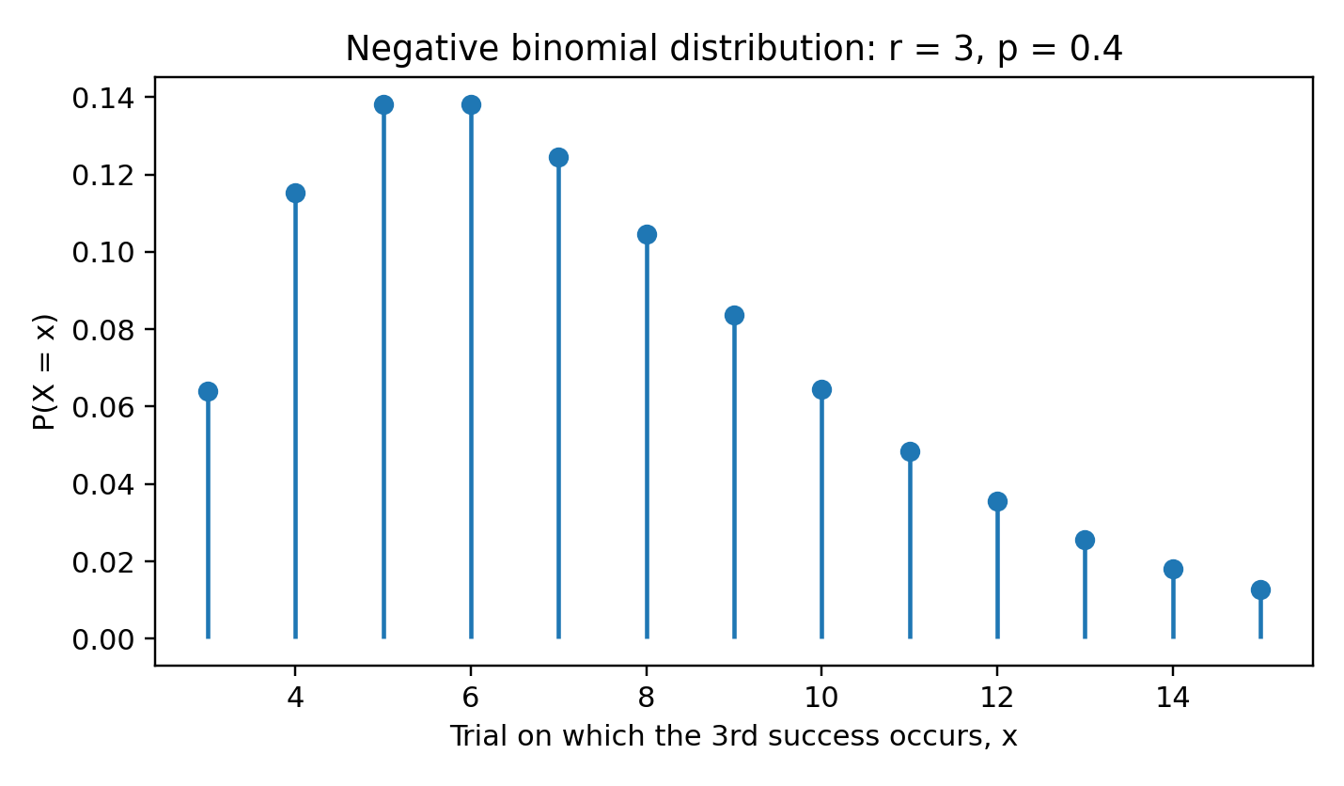
Negative binomial probability mass function

Alternative convention
Some texts define $Y=X-r$ as the number of failures before the $r$th success. Then
$$P\left(Y=y\right)=\left({y+r-1 \atop r-1}\right)p^{r}q^{y}, y=0,1,2,…,$$
with
$$E\left(Y\right)=\frac{rq}{p}, Var\left(Y\right)=\frac{rq}{p^{2}}.$$
Always state the convention before using a formula.

Geometric Distribution
For $r=1$, $X$ is the trial of the first success:
$$P\left(X=x\right)=pq^{x-1}, x=1,2,….$$
Its mean and variance are
$$E\left(X\right)=\frac{1}{p},$$
$$Var\left(X\right)=\frac{q}{p^{2}}.$$
The tail probability is
$$P\left(X>k\right)=q^{k}.$$

Memoryless Property
The geometric distribution is memoryless:
$$P\left(X>s+t∣X>s\right)=P\left(X>t\right).$$
After $s$ failures, the waiting time distribution for the first success is unchanged because Bernoulli trials are independent and have constant success probability.

Example 8.1
A salesperson closes a sale with probability 0.25 on each independent call. The probability that the first sale occurs on the fifth call is
$${\left(0.75\right)}^{4}\left(0.25\right)≈0.0791.$$
The expected number of calls is
$$E\left(X\right)=\frac{1}{0.25}=4.$$

Example 8.2
If a laboratory test succeeds with probability 0.6, the probability that the third success occurs on the fifth trial is
$$\left({4 \atop 2}\right){\left(0.6\right)}^{3}{\left(0.4\right)}^{2}=0.20736.$$

Post-Test
- State the support of the trial-count negative binomial variable.
- If $X$ is geometric with $p=0.2$, find $P\left(X=4\right)$ and $P\left(X>4\right)$.
- Find the mean and variance of a negative binomial variable with $r=5$ and $p=0.4$.
- Explain the difference between “trials until the $r$th success” and “failures before the $r$th success”.
- Prove the memoryless property using the tail probability.
Selected answers: 2. $0.2{\left(0.8\right)}^{3}=0.1024$, ${\left(0.8\right)}^{4}=0.4096$; 3. $12.5$ and $18.75$.

LECTURE NINE: The Poisson Distribution

Introduction
The Poisson distribution models counts of events occurring randomly in a fixed interval of time, space, area or volume. It is appropriate when events occur independently at a stable average rate and simultaneous events in a very small interval are negligible.

Learning Objectives
You should be able to:
- recognise a Poisson count model;
- calculate Poisson probabilities;
- derive its mean, variance and MGF;
- explain its process assumptions and additivity; and
- use it as an approximation to the binomial distribution.

Poisson Probability Function
A random variable $X$ has a Poisson distribution with parameter $λ>0$, written $X∼Pois\left(λ\right)$, if
$$P\left(X=x\right)=e^{-λ}\frac{λ^{x}}{x!}, x=0,1,2,….$$
The parameter $λ$ is both the mean and variance:
$$E\left(X\right)=λ,$$
$$Var\left(X\right)=λ.$$
The MGF is
$$M_{X}\left(t\right)=exp\{λ\left(e^{t}-1\right)\}.$$
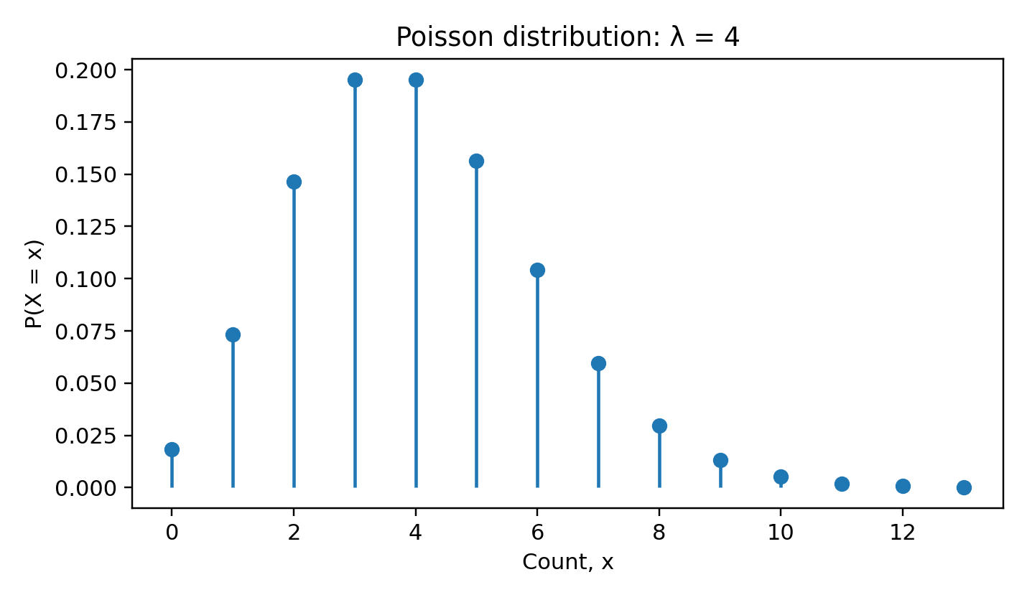
Poisson probability mass function

Poisson Process Interpretation
For a homogeneous Poisson process with rate $ρ$ per unit interval, the count in an interval of length $t$ has parameter
$$λ=ρt.$$
The model assumes:
- counts in disjoint intervals are independent;
- the event rate is constant;
- the probability of one event in a very short interval is approximately proportional to its length; and
- the probability of two or more events in a very short interval is negligible relative to its length.

Example 9.1: Calls
A help desk receives an average of 4 calls per 10 minutes. The probability of exactly 6 calls in 10 minutes is
$$e^{-4}\frac{4^{6}}{6!}≈0.1042.$$
The probability of no calls is
$$P\left(X=0\right)=e^{-4}≈0.0183.$$

Recurrence Relation
Successive probabilities satisfy
$$P\left(X=x+1\right)=\frac{λ}{x+1}P\left(X=x\right).$$

Additivity
If $X_{i}∼Pois\left(λ_{i}\right)$ are independent, then
$$\sum_{i=1}^{n}{X_{i}}∼Pois\left(\sum_{i=1}^{n}{λ_{i}}\right).$$
This follows immediately by multiplying their MGFs.

Poisson Limit of the Binomial
If $X_{n}∼Bin\left(n,p_{n}\right)$, $n→∞$, $p_{n}→0$, and $np_{n}→λ$, then
$$P\left(X_{n}=x\right)→e^{-λ}\frac{λ^{x}}{x!}.$$
This justifies the approximation
$$Bin\left(n,p\right)≈Pois\left(np\right)$$
when $n$ is large and $p$ is small. A common practical guide is $p≤0.05$ and $np$ not too large, though accuracy should be assessed in context.

Example 9.2: Rare defects
In 200 independent items, each has defect probability 0.01. With $λ=np=2$,
$$P\left(X≤1\right)≈e^{-2}\left(1+2\right)=3e^{-2}≈0.4060.$$

Post-Test
- State the Poisson PMF and support.
- If $X∼Pois\left(3\right)$, find $P\left(X=0\right)$ and $P\left(X≥1\right)$.
- Calls arrive at 6 per hour. Find the probability of 2 calls in 20 minutes.
- If $X∼Pois\left(2\right)$ and $Y∼Pois\left(5\right)$ are independent, state the distribution of $X+Y$.
- Approximate $P\left(X=0\right)$ for $X∼Bin\left(500,0.004\right)$ using a Poisson model.
Selected answers: 2. $e^{-3}$ and $1-e^{-3}$; 3. with $λ=2$, $P\left(X=2\right)=2e^{-2}$; 4. $Pois\left(7\right)$; 5. $e^{-2}$.

LECTURE TEN: The Hypergeometric Distribution

Introduction
The hypergeometric distribution models sampling without replacement from a finite population containing two types of item. Unlike the binomial model, successive draws are dependent because the population composition changes after each draw.

Learning Objectives
You should be able to:
- recognise hypergeometric sampling;
- determine the correct support;
- calculate probabilities, means and variances;
- apply the finite-population correction; and
- compare hypergeometric and binomial models.

Probability Function
Suppose a population of size $N$ contains $K$ successes and $N-K$ failures. A sample of size $n$ is drawn without replacement. If $X$ is the number of successes in the sample, then
$$P\left(X=x\right)=\frac{\left({K \atop x}\right)\left({N-K \atop n-x}\right)}{\left({N \atop n}\right)}.$$
The support is
$$max\{0,n-\left(N-K\right)\}≤x≤min\{n,K\}.$$
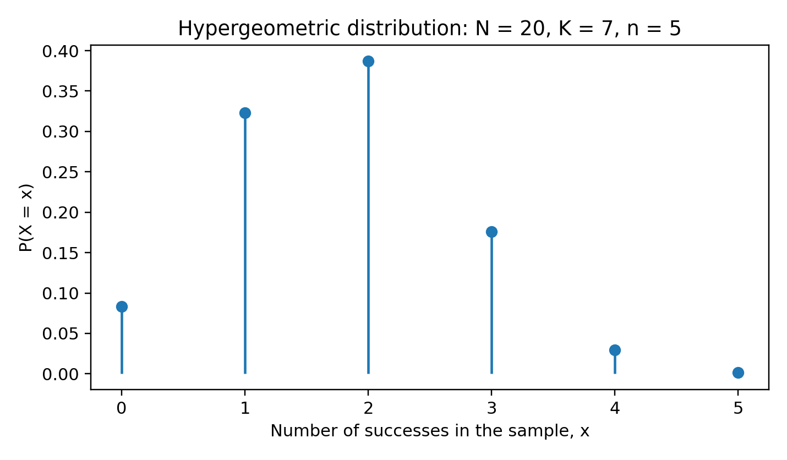
Hypergeometric probability mass function

Mean and Variance
Let
$$p=\frac{K}{N}.$$
Then
$$E\left(X\right)=np,$$
$$Var\left(X\right)=np\left(1-p\right)\frac{N-n}{N-1}.$$
The factor
$$\frac{N-n}{N-1}$$
is the finite-population correction. It makes the hypergeometric variance smaller than the binomial variance $np\left(1-p\right)$ because sampling without replacement contains less randomness.

Example 10.1
A batch of 20 components contains 5 defective items. A sample of 4 is selected without replacement. The probability of exactly 2 defects is
$$\frac{\left({5 \atop 2}\right)\left({15 \atop 2}\right)}{\left({20 \atop 4}\right)}=\frac{1050}{4845}≈0.2167.$$
The mean is
$$E\left(X\right)=4\left(\frac{5}{20}\right)=1.$$
The variance is
$$4\left(\frac{1}{4}\right)\left(\frac{3}{4}\right)\left(\frac{16}{19}\right)≈0.6316.$$

Hypergeometric-to-Binomial Approximation
When the sampling fraction $n/N$ is small, the population composition changes very little and the draws are approximately independent. Then
$$X≈Bin\left(n,\frac{K}{N}\right).$$
A common guide is that the approximation is reasonable when $n/N≤0.05$, though context and required precision matter.

Example 10.2: Model choice
From a population of 1,000 items with 100 defective items, a sample of 5 gives $n/N=0.005$. A binomial approximation with $p=0.1$ is usually accurate. From a population of 20 with 2 defective items and a sample of 10, the sampling fraction is 0.5; the exact hypergeometric model is essential.

Post-Test
- State the difference between binomial and hypergeometric sampling.
- A population of 30 contains 8 successes. A sample of 6 is selected without replacement. Find $P\left(X=2\right)$.
- For Question 2, find $E\left(X\right)$ and $Var\left(X\right)$.
- Explain the finite-population correction.
- When is a binomial approximation to the hypergeometric distribution reasonable?
Selected answers: 2. $\frac{\left({8 \atop 2}\right)\left({22 \atop 4}\right)}{\left({30 \atop 6}\right)}$; 3. $1.6$ and $6\left(8/30\right)\left(22/30\right)\left(24/29\right)≈0.971$.

LECTURE ELEVEN: The Uniform or Rectangular Distribution

Introduction
A continuous uniform distribution assigns equal density to all points in a finite interval. It is appropriate when only the lower and upper bounds are known and no value within the interval is favoured.

Learning Objectives
You should be able to:
- state the uniform PDF and CDF;
- calculate interval probabilities;
- derive the mean and variance; and
- transform a uniform random variable linearly.

Density and Distribution Functions
If $X∼U\left(a,b\right)$ with $a<b$, then
$$f_{X}\left(x\right)=\left\{\begin{matrix}\frac{1}{b-a}, & a≤x≤b, \\ 0, & \text{otherwise}.\end{matrix}\right.$$
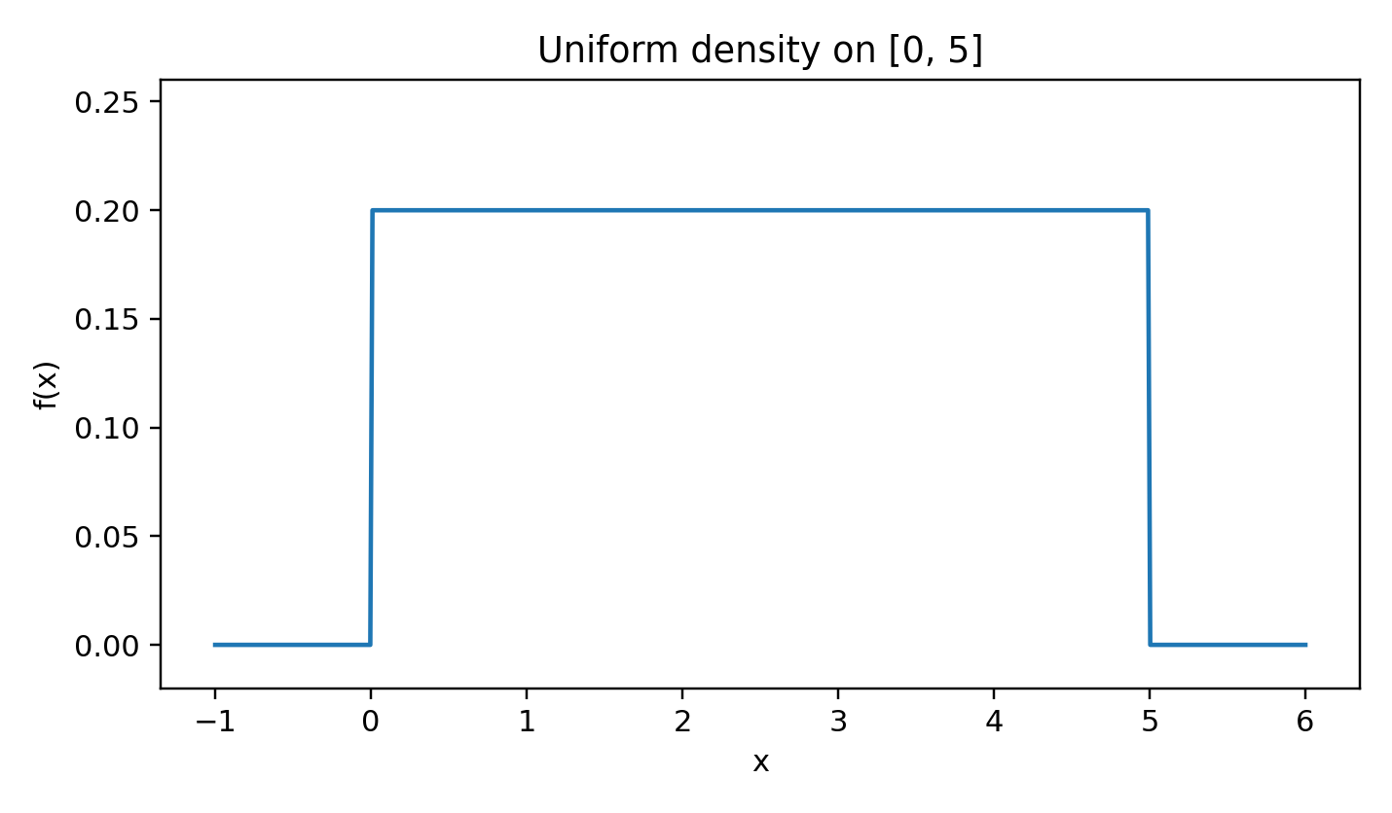
Uniform probability density function
The CDF is
$$F_{X}\left(x\right)=\left\{\begin{matrix}0, & x<a, \\ \frac{x-a}{b-a}, & a≤x≤b, \\ 1, & x>b.\end{matrix}\right.$$
For $a≤c<d≤b$,
$$P\left(c≤X≤d\right)=\frac{d-c}{b-a}.$$
Probability is proportional to interval length.

Mean and Variance
$$E\left(X\right)=\frac{a+b}{2},$$
$$Var\left(X\right)=\frac{{\left(b-a\right)}^{2}}{12}.$$
The median and all central symmetry points equal $\left(a+b\right)/2$.
The $p$th quantile is
$$x_{p}=a+p\left(b-a\right), 0<p<1.$$
The MGF, for $t≠0$, is
$$M_{X}\left(t\right)=\frac{e^{tb}-e^{ta}}{t\left(b-a\right)},$$
with $M_{X}\left(0\right)=1$ by continuity.

Example 11.1
A bus arrives uniformly between 10 and 20 minutes from now. Let $X∼U\left(10,20\right)$. The probability that the wait is between 12 and 15 minutes is
$$\frac{15-12}{20-10}=0.3.$$
The expected wait is
$$E\left(X\right)=\frac{10+20}{2}=15\text{ minutes}.$$

Linear Transformation
If $X∼U\left(a,b\right)$ and $Y=c+dX$ with $d>0$, then
$$Y∼U\left(c+da,c+db\right).$$
If $d<0$, the endpoints are reversed and should be reordered.

Example 11.2: Generating a uniform interval
If $U∼U\left(0,1\right)$, then
$$X=a+\left(b-a\right)U$$
has distribution $U\left(a,b\right)$. This transformation is fundamental in random-number generation.

Post-Test
- State the PDF and CDF of $U\left(a,b\right)$.
- If $X∼U\left(2,8\right)$, find $P\left(3<X<5\right)$.
- For Question 2, find the mean and variance.
- Find the 90th percentile of $U\left(10,30\right)$.
- If $U∼U\left(0,1\right)$, state the distribution of $Y=5+4U$.
Selected answers: 2. $1/3$; 3. $5$ and $3$; 4. $28$; 5. $U\left(5,9\right)$.

LECTURE TWELVE: The Normal Distribution

Introduction
The normal distribution is central to probability and statistics because it models many approximately symmetric measurements and arises as the limiting distribution of standardised sums under broad conditions.

Learning Objectives
You should be able to:
- state the normal density and its properties;
- standardise normal variables;
- calculate probabilities using the standard normal distribution;
- use linear transformation and additivity; and
- apply a normal approximation to the binomial distribution.

Normal Density
A random variable $X$ has a normal distribution with mean $μ$ and variance $σ^{2}$, written
$$X∼N\left(μ,σ^{2}\right),$$
if
$$f_{X}\left(x\right)=\frac{1}{σ\sqrt{2π}}exp\left[-\frac{{\left(x-μ\right)}^{2}}{2σ^{2}}\right], -∞<x<∞.$$
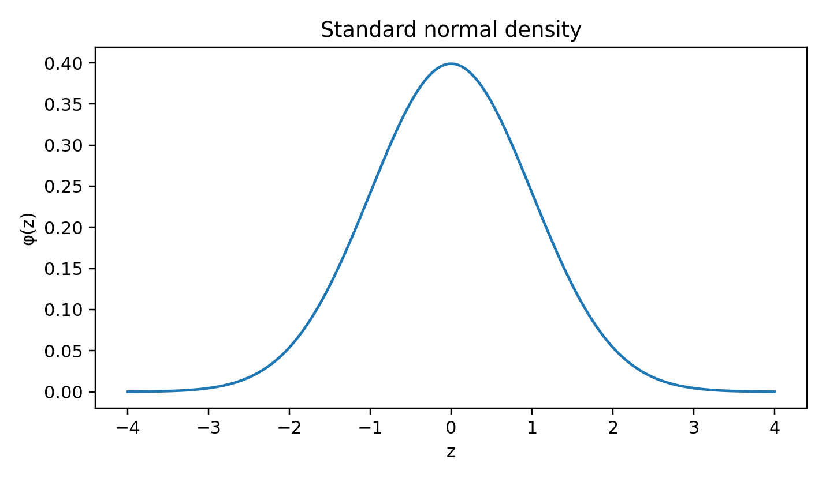
Standard normal probability density function
The density is symmetric about $μ$, with mean, median and mode all equal to $μ$.

Standardisation
If $X∼N\left(μ,σ^{2}\right)$, then
$$Z=\frac{X-μ}{σ}∼N\left(0,1\right).$$
Therefore,
$$P\left(a<X<b\right)=P\left(\frac{a-μ}{σ}<Z<\frac{b-μ}{σ}\right).$$
Let $Φ\left(z\right)=P\left(Z≤z\right)$ denote the standard normal CDF. Symmetry gives
$$Φ\left(-z\right)=1-Φ\left(z\right).$$

Example 12.1
Suppose examination scores are normal with mean 60 and standard deviation 8. The probability that a score exceeds 72 is
$$P\left(X>72\right)=P\left(Z>\frac{72-60}{8}\right)=P\left(Z>1.5\right).$$
Using the standard normal table,
$$P\left(Z>1.5\right)=1-Φ\left(1.5\right)≈0.0668.$$

MGF and Linear Transformation
The MGF is
$$M_{X}\left(t\right)=exp\left(μt+\frac{1}{2}σ^{2}t^{2}\right).$$
If $Y=a+bX$, then
$$Y∼N\left(a+bμ,b^{2}σ^{2}\right).$$

Additivity
If $X_{i}∼N\left(μ_{i},σ_{i}^{2}\right)$ are independent, then
$$\sum_{i=1}^{n}{X_{i}}∼N\left(\sum_{i=1}^{n}{μ_{i}},\sum_{i=1}^{n}{σ_{i}^{2}}\right).$$
More generally, any linear combination of jointly normal variables is normal.

Empirical Rule
For a normal distribution, approximately:
$$P\left(\left|X-μ\right|<σ\right)≈0.6827,$$
$$P\left(\left|X-μ\right|<2σ\right)≈0.9545,$$
$$P\left(\left|X-μ\right|<3σ\right)≈0.9973.$$

Normal Approximation to the Binomial
If $X∼Bin\left(n,p\right)$ and both $np$ and $nq$ are sufficiently large, then
$$X≈N\left(np,npq\right).$$
Because the binomial is discrete and the normal is continuous, use a continuity correction. For example,
$$P\left(X≤x\right)≈P\left(Y≤x+0.5\right),$$
where $Y∼N\left(np,npq\right)$.

Example 12.2
Let $X∼Bin\left(100,0.4\right)$. Approximate $P\left(X≤45\right)$.
Here $μ=40$ and $σ=\sqrt{24}≈4.899$. With continuity correction,
$$P\left(X≤45\right)≈P\left(Z≤\frac{45.5-40}{4.899}\right)=P\left(Z≤1.123\right)≈0.869.$$

Post-Test
- State the normal PDF and standardisation formula.
- If $X∼N\left(50,100\right)$, find $P\left(X>65\right)$ in terms of $Φ$.
- If $X∼N\left(10,4\right)$ and $Y=3X-2$, state the distribution of $Y$.
- Independent variables have distributions $N\left(5,4\right)$ and $N\left(2,9\right)$. State the distribution of their sum.
- Explain the continuity correction in a normal approximation to the binomial.
Selected answers: 2. $1-Φ\left(1.5\right)$; 3. $N\left(28,36\right)$; 4. $N\left(7,13\right)$.

LECTURE THIRTEEN: Joint, Marginal and Conditional Distributions

Introduction
A joint distribution describes two or more random variables simultaneously. It allows probabilities involving combinations of variables, and it provides marginal distributions, conditional distributions, covariance and correlation.

Learning Objectives
You should be able to:
- construct and interpret joint PMFs and PDFs;
- obtain marginal and conditional distributions;
- test independence by factorisation;
- calculate covariance and correlation; and
- find the mean and variance of sums.

Joint Discrete Distributions
For discrete $X$ and $Y$, the joint PMF is
$$p_{X,Y}\left(x,y\right)=P\left(X=x,Y=y\right),$$
with
pX,Yx,y≥0, x​y​pX,Yx,y=1.
The marginal PMFs are
pXx=y​pX,Yx,y,
pYy=x​pX,Yx,y.
The conditional PMF is
$$p_{X∣Y}\left(x∣y\right)=\frac{p_{X,Y}\left(x,y\right)}{p_{Y}\left(y\right)}, p_{Y}\left(y\right)>0.$$

Example 13.1: Joint table
Suppose the joint PMF is
$$X∖Y$$ | 0 | 1 | 2 | Row total
0 | 0.10 | 0.15 | 0.05 | 0.30
1 | 0.20 | 0.30 | 0.20 | 0.70
Column total | 0.30 | 0.45 | 0.25 | 1.00
Then
$$P\left(X=1∣Y=2\right)=\frac{0.20}{0.25}=0.8.$$

Joint Continuous Distributions
A joint PDF satisfies
$$f_{X,Y}\left(x,y\right)≥0,$$
$$\int_{-∞}^{∞}{\int_{-∞}^{∞}{f_{X,Y}}}\left(x,y\right) dx dy=1.$$
For a region $R$,
PX,Y∈R=R​fX,Yx,y dx dy.
The marginal densities are
$$f_{X}\left(x\right)=\int_{-∞}^{∞}{f_{X,Y}}\left(x,y\right) dy,$$
$$f_{Y}\left(y\right)=\int_{-∞}^{∞}{f_{X,Y}}\left(x,y\right) dx.$$
The conditional density is
$$f_{X∣Y}\left(x∣y\right)=\frac{f_{X,Y}\left(x,y\right)}{f_{Y}\left(y\right)}.$$

Independence
Discrete variables are independent if
$$p_{X,Y}\left(x,y\right)=p_{X}\left(x\right)p_{Y}\left(y\right)$$
for every support point. Continuous variables are independent if
$$f_{X,Y}\left(x,y\right)=f_{X}\left(x\right)f_{Y}\left(y\right)$$
throughout the support.
A rectangular support alone does not prove independence; the density must also factorise.

Joint Expectation
For a function $g$,
EgX,Y=x​y​gx,ypX,Yx,y
or
$$E\left[g\left(X,Y\right)\right]=∫∫g\left(x,y\right)f_{X,Y}\left(x,y\right) dx dy.$$

Covariance and Correlation
The covariance is
$$Cov\left(X,Y\right)=E\left[\left(X-E\left(X\right)\right)\left(Y-E\left(Y\right)\right)\right]$$
or
$$Cov\left(X,Y\right)=E\left(XY\right)-E\left(X\right)E\left(Y\right).$$
The correlation coefficient is
$$ρ_{XY}=\frac{Cov\left(X,Y\right)}{σ_{X}σ_{Y}},$$
where $-1≤ρ_{XY}≤1$.
Independence implies zero covariance when the required moments exist, but zero covariance does not generally imply independence.

Sums and Linear Combinations
For constants $a,b,c,d$,
$$Cov\left(aX+b,cY+d\right)=acCov\left(X,Y\right).$$
The variance of a sum is
$$Var\left(X+Y\right)=Var\left(X\right)+Var\left(Y\right)+2Cov\left(X,Y\right).$$
If $X$ and $Y$ are independent,
$$Var\left(X+Y\right)=Var\left(X\right)+Var\left(Y\right).$$

Post-Test
- Define a joint PMF and state its normalisation condition.
- Explain how to obtain a marginal distribution.
- If $E\left(X\right)=2$, $E\left(Y\right)=3$ and $E\left(XY\right)=8$, find $Cov\left(X,Y\right)$.
- If $Var\left(X\right)=4$, $Var\left(Y\right)=9$ and $Cov\left(X,Y\right)=2$, find $Var\left(X+Y\right)$.
- Does zero correlation always imply independence? Explain.
Selected answers: 3. $2$; 4. $17$; 5. No, except under additional conditions such as joint normality.

LECTURE FOURTEEN: Distributions of Functions of Random Variables

Introduction
Transformations convert known random variables into new ones. The main methods are direct use of the CDF, change of variables with a derivative or Jacobian, and convolution for sums. These methods also lead naturally to convergence concepts and the Central Limit Theorem.

Learning Objectives
You should be able to:
- find the distribution of a one-to-one transformation;
- use the CDF method for non-monotone transformations;
- apply a Jacobian for bivariate transformations;
- derive distributions of sums by convolution; and
- state the Law of Large Numbers and Central Limit Theorem.

Univariate Transformations
Let $Y=g\left(X\right)$, where $g$ is one-to-one and differentiable. If $x=g^{-1}\left(y\right)$, then
$$f_{Y}\left(y\right)=f_{X}\left(g^{-1}\left(y\right)\right)\left|\frac{d}{dy}g^{-1}\left(y\right)\right|.$$
The absolute derivative adjusts for stretching or compression of the measurement scale.

Example 14.1: Linear transformation
If $Y=a+bX$, $b≠0$, then
$$f_{Y}\left(y\right)=\frac{1}{\left|b\right|}f_{X}\left(\frac{y-a}{b}\right).$$

CDF method
For any transformation,
$$F_{Y}\left(y\right)=P\left(g\left(X\right)≤y\right).$$
After obtaining $F_{Y}$, differentiate if a density is required.

Example 14.2: Squaring a symmetric variable
Let $X∼U\left(-1,1\right)$ and $Y=X^{2}$. For $0<y<1$,
$$F_{Y}\left(y\right)=P\left(X^{2}≤y\right)=P\left(-\sqrt{y}≤X≤\sqrt{y}\right)=\sqrt{y}.$$
Therefore,
$$f_{Y}\left(y\right)=\frac{1}{2\sqrt{y}}, 0<y<1.$$
The transformation is not one-to-one, so both roots must be included.

Bivariate Transformations and Jacobians
Let
$$U=g_{1}\left(X,Y\right), V=g_{2}\left(X,Y\right),$$
with inverse
$$X=h_{1}\left(U,V\right), Y=h_{2}\left(U,V\right).$$
Then
$$f_{U,V}\left(u,v\right)=f_{X,Y}\left(h_{1}\left(u,v\right),h_{2}\left(u,v\right)\right)\left|J\right|,$$
where
$$J=\frac{∂\left(x,y\right)}{∂\left(u,v\right)}=∣\begin{matrix}\frac{∂x}{∂u} & \frac{∂x}{∂v} \\ \frac{∂y}{∂u} & \frac{∂y}{∂v}\end{matrix}∣.$$
The transformed support must be derived explicitly; a correct Jacobian with an incorrect support gives an incorrect density.

Convolution for Sums
If $X$ and $Y$ are independent continuous random variables and $S=X+Y$, then
$$f_{S}\left(s\right)=\int_{-∞}^{∞}{f_{X}}\left(x\right)f_{Y}\left(s-x\right) dx.$$
For discrete variables,
PS=s=x​PX=xPY=s-x.

Example 14.3: Sum of two uniform variables
If $X,Y∼U\left(0,1\right)$ independently, then $S=X+Y$ has density
$$f_{S}\left(s\right)=\left\{\begin{matrix}s, & 0<s<1, \\ 2-s, & 1≤s<2, \\ 0, & \text{otherwise}.\end{matrix}\right.$$

Convergence Concepts
A sequence $X_{n}$ converges in probability to $X$ if, for every $ε>0$,
$$P\left(\left|X_{n}-X\right|>ε\right)→0.$$
It converges in distribution if
$$F_{X_{n}}\left(x\right)→F_{X}\left(x\right)$$
at every continuity point of $F_{X}$.
Convergence in probability implies convergence in distribution, but the converse is not generally true.

Weak Law of Large Numbers
If $X_{1},X_{2},…$ are independent and identically distributed with mean $μ$ and finite variance, then the sample mean
$${\overset{‾}{X}}_{n}=\frac{1}{n}\sum_{i=1}^{n}{X_{i}}$$
satisfies
$${\overset{‾}{X}}_{n}\overset{P}{→}μ.$$
Thus, averages stabilise near the population mean as the sample size grows.

Central Limit Theorem
If $X_{1},X_{2},…$ are iid with mean $μ$ and finite positive variance $σ^{2}$, then
$$\frac{\sum_{i=1}^{n}{X_{i}}-nμ}{σ\sqrt{n}}\overset{d}{→}N\left(0,1\right).$$
Equivalently, for large $n$,
$${\overset{‾}{X}}_{n}≈N\left(μ,\frac{σ^{2}}{n}\right).$$
The CLT concerns the distribution of a sum or average, not necessarily the distribution of the individual observations.

Example 14.4
A population has mean 80 and standard deviation 12. For samples of size 36,
$$\overset{‾}{X}≈N\left(80,\frac{{12}^{2}}{36}\right)=N\left(80,4\right).$$
Thus,
$$P\left(78<\overset{‾}{X}<83\right)≈P\left(-1<Z<1.5\right)≈0.7745.$$

Post-Test
- State the one-to-one transformation formula.
- Why is an absolute value used in the derivative or Jacobian?
- State the convolution formula for a sum of independent continuous variables.
- Distinguish convergence in probability from convergence in distribution.
- State the Central Limit Theorem and explain what it approximates.

LECTURE FIFTEEN: The Gamma and Chi-Square Distributions

Introduction
The gamma family models positive, right-skewed quantities such as waiting times, lifetimes and aggregate durations. The exponential distribution is a gamma special case, while the chi-square distribution is a re-parameterised gamma distribution central to inference about variances.

Learning Objectives
You should be able to:
- define and use the gamma function;
- state the gamma density under a clear parameterisation;
- calculate gamma probabilities, means, variances and MGFs;
- explain exponential and chi-square special cases; and
- use additivity within the gamma family.

Gamma Function
For $α>0$,
$$Γ\left(α\right)=\int_{0}^{∞}{x^{α-1}}e^{-x} dx.$$
The recurrence relation is
$$Γ\left(α+1\right)=αΓ\left(α\right).$$
For positive integers $n$,
$$Γ\left(n\right)=\left(n-1\right)!.$$
Also,
$$Γ\left(\frac{1}{2}\right)=\sqrt{π}.$$

Gamma Distribution: Shape-Rate Form
This course uses the shape-rate parameterisation. If $X∼Gamma\left(α,β\right)$, where $α>0$ is the shape and $β>0$ is the rate, then
$$f_{X}\left(x\right)=\frac{β^{α}}{Γ\left(α\right)}x^{α-1}e^{-βx}, x>0.$$
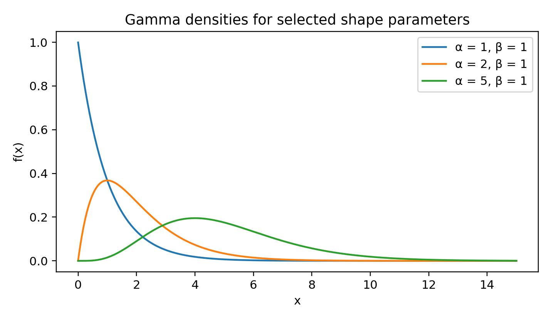
Gamma probability density functions
The mean and variance are
$$E\left(X\right)=\frac{α}{β},$$
$$Var\left(X\right)=\frac{α}{β^{2}}.$$
The MGF is
$$M_{X}\left(t\right)={\left(\frac{β}{β-t}\right)}^{α}, t<β.$$

Shape-scale notation
Some texts use scale $θ=1/β$. Then
$$f_{X}\left(x\right)=\frac{x^{α-1}e^{-x/θ}}{Γ\left(α\right)θ^{α}},$$
$$E\left(X\right)=αθ, Var\left(X\right)=αθ^{2}.$$
The two parameterisations must not be mixed.

Exponential Distribution
When $α=1$,
$$f_{X}\left(x\right)=βe^{-βx}, x>0,$$
which is the exponential distribution with rate $β$. Its survival function is
$$P\left(X>x\right)=e^{-βx}.$$
Like the geometric distribution, the exponential distribution is memoryless:
$$P\left(X>s+t∣X>s\right)=P\left(X>t\right).$$

Additivity
If $X_{i}∼Gamma\left(α_{i},β\right)$ are independent with a common rate $β$, then
$$\sum_{i=1}^{n}{X_{i}}∼Gamma\left(\sum_{i=1}^{n}{α_{i}},β\right).$$
A common rate is required.

Example 15.1
If independent service stages have distributions $Gamma\left(2,0.5\right)$ and $Gamma\left(3,0.5\right)$, their total time has distribution
$$Gamma\left(5,0.5\right).$$
Its mean is $5/0.5=10$ and variance is $5/{\left(0.5\right)}^{2}=20$.

Chi-Square Distribution
A chi-square variable with $ν$ degrees of freedom is a gamma variable with
$$α=\frac{ν}{2}, β=\frac{1}{2}.$$
Thus,
$$X∼χ_{ν}^{2} ⇔ X∼Gamma\left(\frac{ν}{2},\frac{1}{2}\right).$$
Its density is
$$f_{X}\left(x\right)=\frac{1}{2^{ν/2}Γ\left(ν/2\right)}x^{ν/2-1}e^{-x/2}, x>0.$$
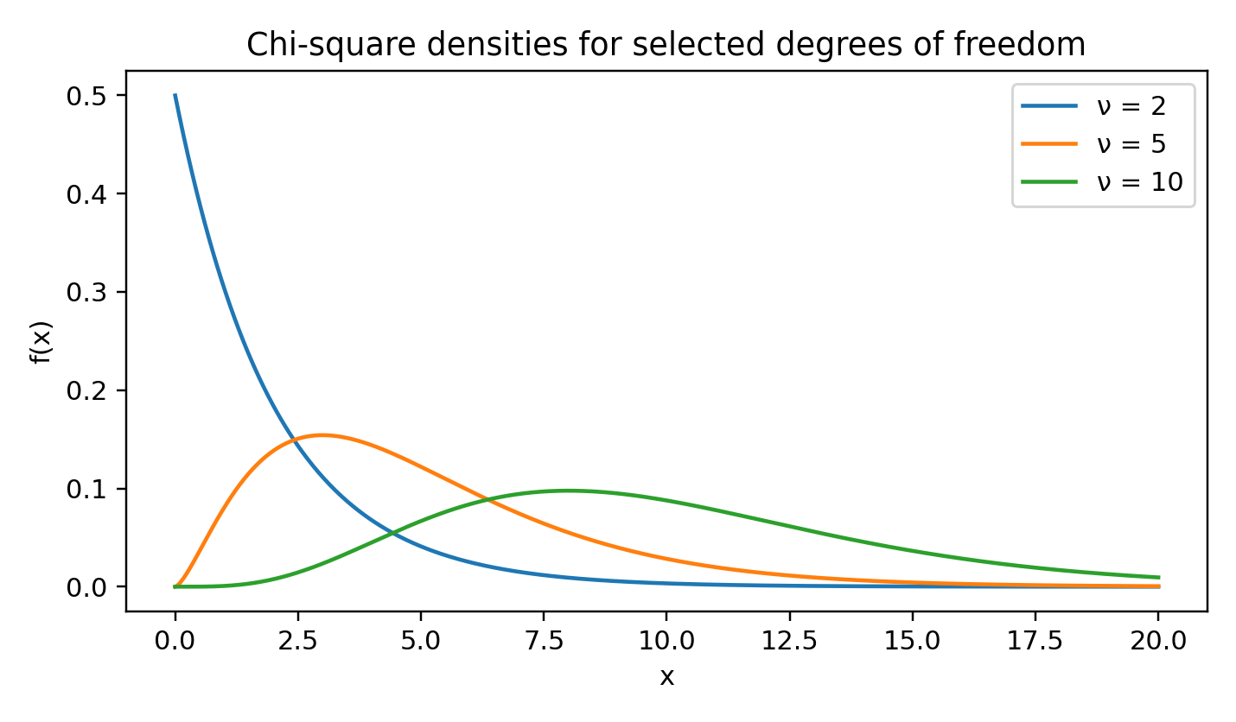
Chi-square probability density functions
The mean and variance are
$$E\left(X\right)=ν,$$
$$Var\left(X\right)=2ν.$$
If $Z_{1},…,Z_{ν}$ are independent standard normal variables, then
$$\sum_{i=1}^{ν}{Z_{i}^{2}}∼χ_{ν}^{2}.$$
If $X_{1},…,X_{n}$ are sampled independently from $N\left(μ,σ^{2}\right)$, then
$$\frac{\left(n-1\right)S^{2}}{σ^{2}}∼χ_{n-1}^{2}.$$
This result underlies confidence intervals and hypothesis tests for a normal population variance.

Post-Test
- State the gamma density under the shape-rate parameterisation.
- If $X∼Gamma\left(4,2\right)$, find its mean and variance.
- Identify the exponential distribution as a gamma special case.
- If $X∼χ_{10}^{2}$, find its mean and variance.
- If $X∼Gamma\left(3,1/2\right)$, express its distribution as chi-square.
- State the condition required for sums of independent gamma variables to remain gamma.
Selected answers: 2. $2$ and $1$; 4. $10$ and $20$; 5. $χ_{6}^{2}$; 6. a common rate, or equivalently a common scale.

Consolidated Formula Sheet

Counting
$$​_{n}P_{r}=\frac{n!}{\left(n-r\right)!}, \left({n \atop r}\right)=\frac{n!}{r!\left(n-r\right)!}.$$
$$\text{Repeated arrangements}=\frac{n!}{n_{1}!n_{2}!⋯n_{k}!}.$$

Probability
$$P\left(A∪B\right)=P\left(A\right)+P\left(B\right)-P\left(A∩B\right).$$
$$P\left(A∣B\right)=\frac{P\left(A∩B\right)}{P\left(B\right)}.$$
PB=i​PB∣AiPAi.
PAj∣B=PB∣AjPAji​PB∣AiPAi.

Expectation and Variance
$$Var\left(X\right)=E\left(X^{2}\right)-{\left[E\left(X\right)\right]}^{2}.$$
$$Var\left(X+Y\right)=Var\left(X\right)+Var\left(Y\right)+2Cov\left(X,Y\right).$$

Distribution Summary
Distribution | Support | Mean | Variance
Bernoulli$\left(p\right)$ | $$0,1$$ | $$p$$ | $$p\left(1-p\right)$$
Binomial$\left(n,p\right)$ | $$0,…,n$$ | $$np$$ | $$np\left(1-p\right)$$
Geometric$\left(p\right)$, trial count | $$1,2,…$$ | $$1/p$$ | $$\left(1-p\right)/p^{2}$$
Negative binomial$\left(r,p\right)$, trial count | $$r,r+1,…$$ | $$r/p$$ | $$r\left(1-p\right)/p^{2}$$
Poisson$\left(λ\right)$ | $$0,1,…$$ | $$λ$$ | $$λ$$
Hypergeometric$\left(N,K,n\right)$ | finite integer range | $$nK/N$$ | $$np\left(1-p\right)\left(N-n\right)/\left(N-1\right)$$
Uniform$\left(a,b\right)$ | $$a≤x≤b$$ | $$\left(a+b\right)/2$$ | $${\left(b-a\right)}^{2}/12$$
Normal$\left(μ,σ^{2}\right)$ | $$R$$ | $$μ$$ | $$σ^{2}$$
Gamma$\left(α,β\right)$, rate form | $$x>0$$ | $$α/β$$ | $$α/β^{2}$$
Chi-square$\left(ν\right)$ | $$x>0$$ | $$ν$$ | $$2ν$$

Revision Notes
The updated edition makes the following substantive improvements:
- all central formulas have been rebuilt as editable equations rather than raster equation fragments;
- notation has been standardised across lectures, including $p=1-q$, distribution supports and gamma parameterisation;
- assumptions are stated before formulas are applied;
- conditional probability, independence, total probability and Bayes’ theorem are presented as a connected sequence;
- PMF, PDF and CDF terminology is distinguished consistently;
- finite-population correction is included for the hypergeometric variance;
- continuity correction is included for normal approximation to the binomial;
- pairwise and mutual independence are distinguished;
- geometric and negative-binomial support conventions are made explicit; and
- distribution additivity is summarised for binomial, Poisson, normal, gamma and chi-square families.

References
Amahia, G. N. STA 211: Probability II. Original course manuscript, Department of Statistics, University of Ibadan.
Cameron, P. J. Notes on Probability. Queen Mary, University of London.
Doedel, E. Lecture Notes on Probability and Statistics.
Gravner, J. (2011). Lecture Notes for Introductory Probability. University of California, Davis.
Kroese, D. P. (2009). A Short Introduction to Probability. Department of Mathematics.
Mejlbro, L. (2009). Introduction to Probability: Probability Examples C-1.
Walrand, J. (2004). Lecture Notes on Probability Theory and Random Processes. University of California, Berkeley.
Young, G. A. (2011). M2S1 Lecture Notes. Imperial College London.
Additional supplied lecture notes on conditional probability, Bayes’ theorem, random variables and probability distributions were used to verify topic coverage and notation.

